AN “ANDESITIC” COMPONENT IN SHERGOTTITES WITH RESTORED LREE ABUNDANCES? L. E. Nyquist¹, C.-Y. Shih², H. Wiesmann², and J. A. Barrat³, ¹Mail Code SR, NASA Johnson Space Center, Houston, TX 77058, l.nyquist@jsc.nasa.gov, ²Mail Code C23, Lockheed-Martin Space Mission Systems and Service Co., 2400 NASA Road 1, Houston, TX 77058, ³Université d’Angers, 2 bd Lavoisier, 49045 Angers Cedex, France.

Introduction: The shergottite Martian meteorites present a variety of oft-confusing petrologic features. In particular, represented among this subgroup are basalts with very depleted LREE abundances, as well as those with nearly chondritic overall REE abundances. The LREE-depleted basalts appear to more closely record the REE and isotopic features of their mantle source regions. Those basalts with more nearly chondritic REE abunandances appear to contain an extra component often referred to as a “crustal” component. The addition of the crustal component tends to restore the overall REE abundance pattern towards chondritic relative abundances. Here we suggest that the crustal component could derive from “andesitic” rocks observed remotely to occur on the Martian surface, and which were analysed at the Pathfinder site.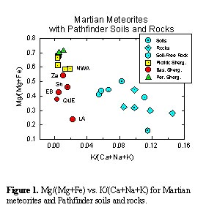
Comparison of Martian meteorites to Pathfinder rocks and soils: Figure 1 compares Mg/(Mg+Fe), i.e., mg-values, and K/(Ca+Na+K) for Martian meteorites to those in Pathfinder rocks and soils [1]. The mg-values are related to olivine abundances in the shergottites. “Picritic basalts” and “peridotitic shergottites” are enriched in olivine compared to the “basaltic shergottites”. However, it is clear that the shergottites cannot be adequately characterized by a single parameter. Also, K/(Ca+Na+K) cannot be identified with a single mineralogical feature of the samples, but was chosen partly to reflect the feldspar composition of the samples, partly to reflect the feldspar composition in possibly assimilated precursor materials, and partly because K has geochemical affinities to both La and Rb. Thus, this parameter might be expected to correlate to the Sm-Nd and Rb-Sr isotopic systematics of the meteorites.
The meteorite and Pathfinder data fields are completely separated in Figure 1. However, the peridotitic shergottites and picritic basalts lie on the extension of the trend of Pathfinder data, and thus could be interpreted as capable of providing a mafic component to the Pathfinder soils. The need for such a component, not represented among the analysed Pathfinder rocks, was recognized by Wänke et al. [1].
Preliminary Nd and Sr isotopic data for NWA 1068: In Figure 1, the picritic basalt displaced most strongly towards the pathfinder data is NWA 1068. It contains large olivine megacrysts characteristic of strongly LREE-depleted picritic basalts like DaG 476 and 489, SaU 005, and EET79001, but it has nearly chondritic relative REE abundances like basaltic shergottites, Shergotty, Zagami, and Los Angeles [2]. We have begun Sr and Nd isotopic investigations of NWA 1068. Comparing preliminary Sm-Nd data to that of Los Angeles (LA), another hot-desert meteorite, shows the effect of terrestrial contamination on analyses of an unleached whole rock (WR) and a leachate from a second whole rock (WR(l)). Sm-Nd of the leach residue, WR(r), are very similar to leach-residue data for LA, and lie on the ~172 Ma isochron determined for LA [3]. The WR and WR(l) data are displaced from WR(r) along a mixing line terminating at the isotopic data for caliche physcially removed from LA. The slope of this mixing line corresponds to a maximum apparent age of 245 Ma. The initial Rb-Sr isotopic data show analogous relationships, with the WR(r) datum falling in the range of values for ~170 Ma isochrons for Shergotty, Zagami, and Los Angeles. Again, the WR and WR(l) data are displaced along a mixing line terminating at the caliche datum. For this discussion, we assume an age of 173 Ma for NWA 1068, characteristic of shergottites with similar REE abundances [4], and calculate initial ¹⁴³Nd/¹⁴⁴Nd and ⁸⁷Sr/⁸⁶Sr ratios from the WR(r) data. Additonal isotopic data will be presented at the workshop.
Olivine accumulation and fractional crystallization in shergottites: Figure 2 shows that magma-chamber and/or near-surface processes of olivine 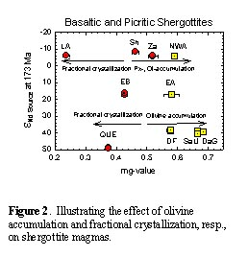accumulation and fractional crystallization have been operative on shergottite magmas of differing isotopic compositions. These effects have operated independently of whether the isotopic systematics were inherited from the Martian mantle directly (meteorites with large, positive values of ε_{Nd}), or likely represent mixing of mantle and crustal components (meteorites with negative ε_{Nd}). Olivine accumulation is manifest in the presence of large megacrysts of olivine in the picritic basalts NWA 1068, EET79001A, Dhofar 019, SaU 005, and DaG 476, 489. The effect of fractional crystallization is manifested in low Mg/(Mg+Fe) for several of the basaltic shergottites, including especially Los Angeles and QUE94201 (Figure 1). Los Angeles has “crustal” isotopic systematics, whereas QUE94201 has “mantle” isotopic systematics (Figure 3). Olivine fractionation clearly occurred after the isotopic and REE characteristics of the magmas were established.
Isotopic mixing relationships: We presented two component isotopic mixing models for the initial Nd- and Sr-isotopic composition in EET79001 and Los Angeles [5]. The simplest scenario, binary mixing, is illustrated in Figure 3, updated from [5].
Because late-stage magma-chamber and near-surface fractionation processes affect the abundances of Sr and Nd in the basalts, but not their isotopic compositions, we allow the abundances of Sr and Nd in the mixing endmembers to vary within reasonable limits. The assumed isotopic characteristics of the crust are fixed by requiring the crustal component in LA to be <20%. To match the isotopic characteristics of LA, a highly fractionated basalt, we use the relatively high Sr and Nd abundances in QUE94201 for the “mantle-derived” basalt mixed with a crustal component with ~30X higher Nd, and 4.4X higher Sr abundances. The parameter K/(Ca+Na+K) = 0.0033 for QUE, ~30X less than for the Pathfinder soils and rocks, so the required 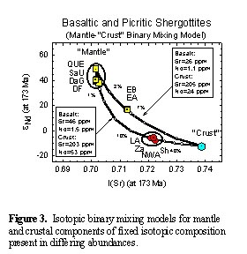level of Nd enrichment (~117 X CI) may be readily available in Martian crustal rocks.
Figure 4 shows the results of an AFC model using the same endmembers as for Figure 3. A high ratio of the rate of assimilation to the rate of crystallization, r = 0.3, is shown for illustration. The amount of assimilant is ~3X higher than for the binary mixing model. The resultant is enriched in Nd and Sr by ~3X for LA, but by only ~20% for EET79001B. Thus, the models are equivalent for EET79001B, not for LA.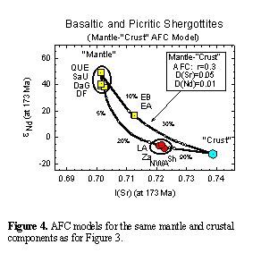
References: [1] Wänke H. et al. (2001), Chron. & Ev. Mars, ISSI, 317-330. [2] Barrat J. A. et al. (2002) Geochim. Cosmochim. Acta (submitted). [3] Nyquist L. E. and Reese Y. D. (2001) Eos Trans. AGU, 82 (47), Fall Mtg. abs. P51A-02. [4] Nyquist L. E. et al. (2001) Chron. & Ev. Mars, ISSI, 105-164. [5] Nyquist L. E. et al. (2001) LPS XXXII, abs. #1407.

